Using JUnits in a Netbeans project

1. Adding a given test folder to an existing project

The test folder should have been created using a Java IDE in such a way that the inner folder has been set up as a package.

* Copy the given test folder into your Netbeans unzipped project at the same level as the src folder
* Open the project in Netbeans and open both the src & the test folders
* Check to see whether the contents of the test folder compile
* If test folder is not compiling, see below

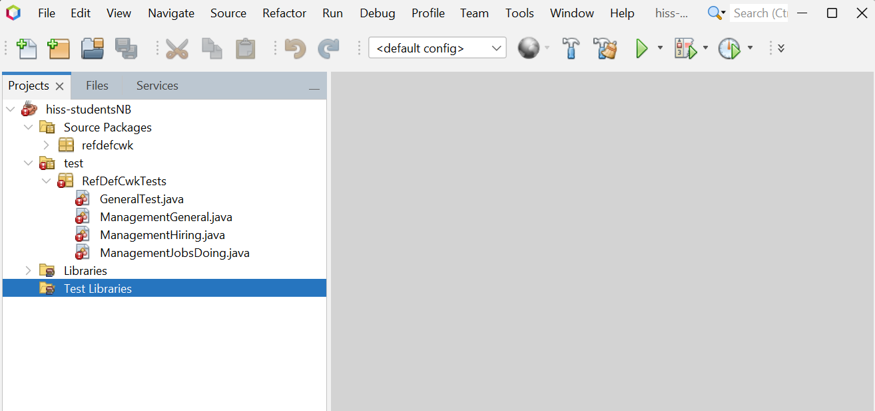

test not compiling

* R-click on "Test Libraries” – Add Library
* Add libraries : Hamcrest 1.3 & JUnit

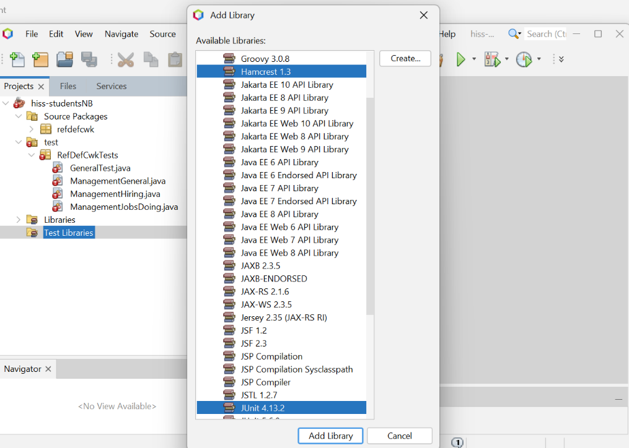

test should now compile

* Trouble shooting
  + If you don’t see Test Libraries, try closing the project and opening again